Cloning

. Cloning is a process of creating a duplicate object from an exisitng object.

. When creating complex objects, cloning is used.

. Instead of creating an object from scratch, we can clone exisiting objec to create a duplicate object.

. Once an object is cloned, the original and duplicate objects acts independently. The changes made to the original object, doesn’t effect on duplicate object and vice-versa.

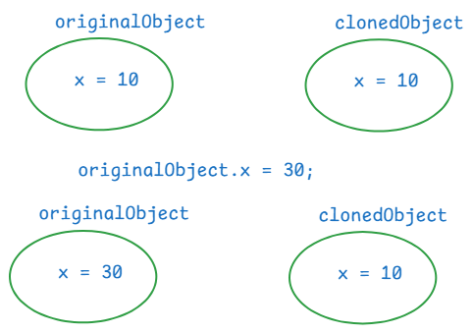

. For example, in a gaming application, we need multiple enemies with the same characterstics. So, we create one enemy object, and we clone this object to create multiple enemies.

How to clone an object?

. first implement a class, whose objects requires cloning from java.lang.Cloneable marker interface.

. we have to override clone() method of Object class, in that class.

//example

**package** com.ashokit.cloning;

**class** ClassA **implements** Cloneable {

**private** **int** x;

**private** **int** y;

ClassA(**int** x, **int** y) {

// System.out.println("ClassA(int,int): constructor");

**this**.x = x;

**this**.y = y;

}

//Here, you are overriding clone() method of Object class

@Override

**protected** Object clone() **throws** CloneNotSupportedException {

**return** **super**.clone();

}

//Here, you are overriding toString() method of Object class

@Override

**public** String toString() {

**return** "ClassA [x=" + x + ", y=" + y + "]";

}

**public** **int** getX() {

**return** x;

}

**public** **void** setX(**int** x) {

**this**.x = x;

}

**public** **int** getY() {

**return** y;

}

**public** **void** setY(**int** y) {

**this**.y = y;

}

}

**public** **class** Main {

**public** **static** **void** main(String[] args) **throws** CloneNotSupportedException {

ClassA ca = **new** ClassA(10, 20);

ClassA clonedCa = (ClassA) ca.clone();

System.***out***.println("original object : " + ca);

System.***out***.println("cloned object : "+ clonedCa);

//make changes to original object

ca.setX(30);

ca.setY(40);

System.***out***.println("==============================");

System.***out***.println("After making changes in original object");

System.***out***.println("original object : " + ca);

System.***out***.println("cloned object : "+ clonedCa);

}

}

output:

original object : ClassA [x=10, y=20]

cloned object : ClassA [x=10, y=20]

==============================

After making changes in original object

original object : ClassA [x=30, y=40]

cloned object : ClassA [x=10, y=20]

Types of cloning:

1. shallow cloning
2. deep cloning

. In shallow cloing, when a dependent object is cloned, its dependency object will not be cloned. It means, both original and cloned dependent objects will share the same dependency object.

. In deep cloning, when a dependent object is cloned, its dependency object is also cloned. So, both original and cloned dependent objects have separate dependency objects.

. In shallow cloning, dependent class implements Cloneable interface, but dependency class doesn’t.

. In deep cloning, both the classes implements Cloneable interface.

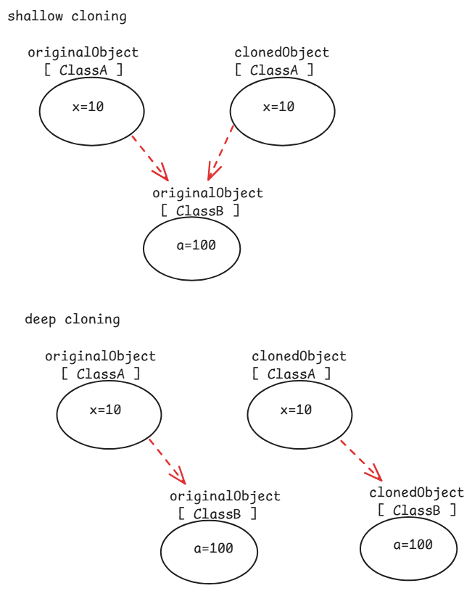

// shallow cloning example

**package** com.ashokit.cloning;

//dependent class

**class** ClassA **implements** Cloneable {

**private** **int** x;

**private** **int** y;

**private** ClassB classB;

ClassA(**int** x, **int** y) {

// System.out.println("ClassA(int,int): constructor");

**this**.x = x;

**this**.y = y;

classB = **new** ClassB(100, 200);

}

@Override

**protected** Object clone() **throws** CloneNotSupportedException {

**return** **super**.clone();

}

@Override

**public** String toString() {

**return** "ClassA [x=" + x + ", y=" + y + ", classB=" + classB + "]";

}

**public** **int** getX() {

**return** x;

}

**public** **void** setX(**int** x) {

**this**.x = x;

}

**public** **int** getY() {

**return** y;

}

**public** **void** setY(**int** y) {

**this**.y = y;

}

**public** ClassB getClassB() {

**return** classB;

}

**public** **void** setClassB(ClassB classB) {

**this**.classB = classB;

}

}

//dependency class

**class** ClassB {

**private** **int** a;

**private** **int** b;

ClassB(**int** a, **int** b) {

**this**.a = a;

**this**.b = b;

}

@Override

**public** String toString() {

**return** "ClassB [a=" + a + ", b=" + b + "]";

}

**public** **int** getA() {

**return** a;

}

**public** **void** setA(**int** a) {

**this**.a = a;

}

**public** **int** getB() {

**return** b;

}

**public** **void** setB(**int** b) {

**this**.b = b;

}

}

**public** **class** Main {

**public** **static** **void** main(String[] args) **throws** CloneNotSupportedException {

ClassA ca = **new** ClassA(10,20);

ClassA clonedCa = (ClassA) ca.clone();

System.***out***.println("original object : " + ca);

System.***out***.println("cloned object : " + clonedCa);

System.***out***.println("======================================");

//making a change in the dependency object through original dependent object

ca.getClassB().setA(99);

ca.getClassB().setB(199);

System.***out***.println("After changing dependency object, through original dependent object");

System.***out***.println("original object : "+ ca);

System.***out***.println("cloned object : " + clonedCa);

}

}

output:

original object : ClassA [x=10, y=20, classB=ClassB [a=100, b=200]]

cloned object : ClassA [x=10, y=20, classB=ClassB [a=100, b=200]]

======================================

After changing dependency object, through original dependent object

original object : ClassA [x=10, y=20, classB=ClassB [a=99, b=199]]

cloned object : ClassA [x=10, y=20, classB=ClassB [a=99, b=199]]

//deep cloning example.

**package** com.ashokit.cloning;

//dependent class

**class** ClassA **implements** Cloneable {

**private** **int** x;

**private** **int** y;

**private** ClassB classB;

ClassA(**int** x, **int** y) {

// System.out.println("ClassA(int,int): constructor");

**this**.x = x;

**this**.y = y;

classB = **new** ClassB(100, 200);

}

@Override

**protected** Object clone() **throws** CloneNotSupportedException {

ClassB clonedB = (ClassB) classB.clone();

ClassA clonedA = (ClassA)**super**.clone();

clonedA.setClassB(clonedB);

**return** clonedA;

}

@Override

**public** String toString() {

**return** "ClassA [x=" + x + ", y=" + y + ", classB=" + classB + "]";

}

**public** **int** getX() {

**return** x;

}

**public** **void** setX(**int** x) {

**this**.x = x;

}

**public** **int** getY() {

**return** y;

}

**public** **void** setY(**int** y) {

**this**.y = y;

}

**public** ClassB getClassB() {

**return** classB;

}

**public** **void** setClassB(ClassB classB) {

**this**.classB = classB;

}

}

//dependency class

**class** ClassB **implements** Cloneable {

**private** **int** a;

**private** **int** b;

ClassB(**int** a, **int** b) {

**this**.a = a;

**this**.b = b;

}

@Override

**protected** Object clone() **throws** CloneNotSupportedException {

**return** **super**.clone();

}

@Override

**public** String toString() {

**return** "ClassB [a=" + a + ", b=" + b + "]";

}

**public** **int** getA() {

**return** a;

}

**public** **void** setA(**int** a) {

**this**.a = a;

}

**public** **int** getB() {

**return** b;

}

**public** **void** setB(**int** b) {

**this**.b = b;

}

}

**public** **class** Main {

**public** **static** **void** main(String[] args) **throws** CloneNotSupportedException {

ClassA ca = **new** ClassA(10,20);

ClassA clonedCa = (ClassA) ca.clone();

System.***out***.println("original object : " + ca);

System.***out***.println("cloned object : " + clonedCa);

System.***out***.println("======================================");

//making a change in the dependency object through original dependent object

ca.getClassB().setA(99);

ca.getClassB().setB(199);

System.***out***.println("After making changes to the dependency object, through original dependent object");

System.***out***.println("original object : "+ ca);

System.***out***.println("cloned object : " + clonedCa);

}

}

output:

original object : ClassA [x=10, y=20, classB=ClassB [a=100, b=200]]

cloned object : ClassA [x=10, y=20, classB=ClassB [a=100, b=200]]

======================================

After making changes to the dependency object, through original dependent object

original object : ClassA [x=10, y=20, classB=ClassB [a=99, b=199]]

cloned object : ClassA [x=10, y=20, classB=ClassB [a=100, b=200]]

serialization & deserialization

* serialization is a process of converting a Java object into a stream of bytes, which can be easily saved in a file, transmitted over a network or stored in a database.
* deserialization is a reverse process of serialization. The stream of bytes are collected from a file, or network, or a database and converted back to a Java object.
* we serialize an object, when we want to save the state of an object into a file, or we want to send an object to another machine.
* To serialize a Java object, the class should implement a marker interface, java.io.Serializable.
* We use ObjectOutputStream class for serialization and ObjectInputStream class for deserialization.
* The writeObject() of ObjectOutputStream class converts a Java object into a stream of bytes.
* The readObject() of ObjectInputStream class converts a stream of bytes into a Java object.

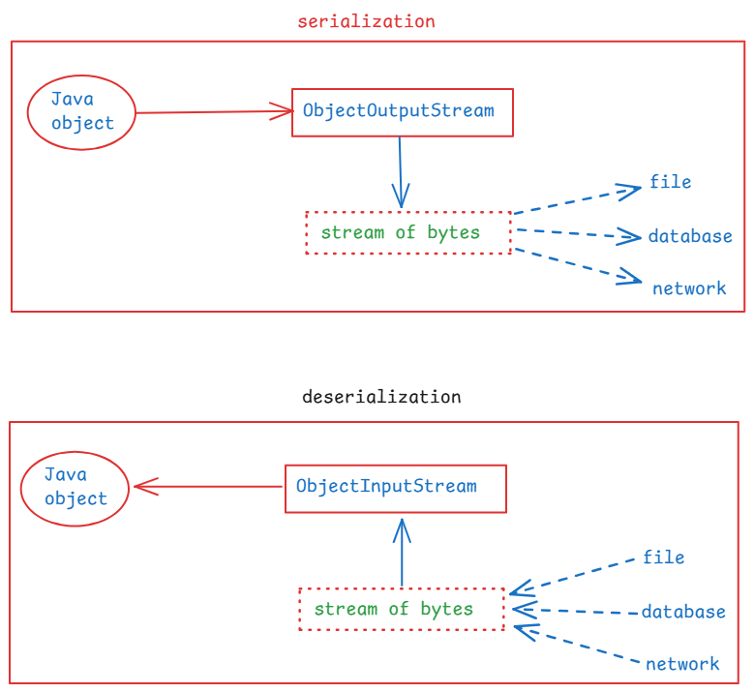

// A demo on serialization

**package** com.ashokit.demo;

**import** java.io.FileInputStream;

**import** java.io.FileOutputStream;

**import** java.io.IOException;

**import** java.io.ObjectInputStream;

**import** java.io.ObjectOutputStream;

**import** java.io.Serializable;

**class** Employee **implements** Serializable {

**int** empno;

String ename;

Employee(**int** empno, String ename) {

**this**.empno = empno;

**this**.ename = ename;

}

@Override

**public** String toString() {

**return** "Employee [empno=" + empno + ", ename=" + ename + "]";

}

}

**public** **class** Main {

**public** **static** **void** main(String[] args) {

Employee emp = **new** Employee(7878, "Scott");

//serialization

**try** ( FileOutputStream fileOut = **new** FileOutputStream("D:\\employee.ser");

ObjectOutputStream out = **new** ObjectOutputStream(fileOut)) {

out.writeObject(emp);

}

**catch**(IOException ie) {

ie.printStackTrace();

}

//deserialization

Employee deserializedEmp = **null**;

**try** ( FileInputStream fileIn = **new** FileInputStream("D:\\employee.ser");

ObjectInputStream in = **new** ObjectInputStream(fileIn)) {

deserializedEmp = (Employee) in.readObject();

}

**catch**(IOException | ClassNotFoundException ex) {

ex.printStackTrace();

}

System.***out***.println("Deserialized Employee : "+ deserializedEmp);

}

}

what is serialVersionUID?

. It is a unique identifier for each class that implements Serializable interface.

. It must be declared as a private static final long variable.

private static final long serialVersionUID = 1L;

. when an object is serialized, the serialVersionUID is also included in the stream of bytes.

. At the time of deserialization, JVM checks the id of the class and the id in the stream of bytes. If they match then only deserialization will proceed.

. Otherwise, JVM throws InvalidClassException.

what is transient keyword?

. If you want to stop any attribute of a class from serialization then you have to declare that variable as transient.

. when an object is serialized, the transient variable value will be stored as null, into the file.

. transient keyword can be used with only variables. Not with classes, interfaces or methods.

For example,

public class User implements Serializable {

private String username;

private transient String password;

//methods

}

( Please also refer Externalizable interface )

enum keyword:

-------------

. enum stands for enumeration.

. enum keyword is used to create a special data type.

. When you want to create a variable and that should be allowed to

store only one of the fixed set of constants as a value, then you

should create a special data type with enum keyword.

ex:

public enum Day {

MONDAY, TUESDAY, WEBNESDAY, THURSDAY, FRIDAY, SATURDAY, SUNDAY

}

. The constants in enum, are implicity static and final. So, we write the constants in upper case, but it is not a strict rule.

. You can create a variable of enum type as,

Day day;

. The variable can store one of the constants.

day = Day.MONDAY;

. Enums can also have fields, constructors and methods.

ex:

Gender.java

**public** **enum** Gender {

***MALE***("Male Person"), ***FEMALE***("Female Person"), ***OTHERS***("Other persons");

**private** String str; //field

Gender(String str) { //constructor

**this**.str = str;

}

**public** String getStr() { //method

**return** str;

}

**public** String sayHello() { //method

**return** "hello";

}

}

TestClass.java

**public** **class** TestClass {

**public** **static** **void** main(String[] args) {

Gender gender = Gender.***MALE***;

System.***out***.println(gender.sayHello()+ " : "+gender.getStr());

Gender gender2 = Gender.***FEMALE***;

System.***out***.println(gender2.sayHello()+ " : "+gender2.getStr());

//values(): returns an array of all enum constants

**for**(Gender g : Gender.*values*()) {

System.***out***.println(g);

}

}

}

JVM internal components:

1. class loader
2. runtime data areas
3. execution engine
4. Java Native Interface(JNI)
5. Native Method libraries

. Class Loader is responsible for loading class files into JVM.

. Before JDK11, we have 3 types of class loaders.

1. Bootstrap class loader: loads the classes from Java API
2. Extension class loader: loads the classes from extensions

directory( jre/lib/ext).

1. Application class loader: loads the classes from the

application classpath

. From JDK11, we have 2 types of class loaders.

1. Bootstrap class loader
2. Application class loader

. Runtime data areas are,

1.method area: stores the class level information.

static variables, class structures and methods are

stored in this method area.

2.heap area: stores objects and arrays.

3.stack area: stores local variables, partial results of threads.

4.PC registers: Each thread has a Program Counter(PC), it holds the

address of the current instruction being executed by

the thread.

5.Native method stack: Manages native(non-Java) method calls.

. Execution Engine: It is responsible for reading byte code and executing it.

. Execution engine contains,

1. interpreter
2. Just-In-Time compiler(JIT)
3. Garbage Collector(GC)

. JNI allows the JVM to interact with native applications written in other languages like C/C++.

. Native method libraries are OS specific libraries and these will perform some tasks related system resources. JVM will access these libraries via JNI.